System Analysis Project Report (IS 421)

**System Analysis of Tinder**

Kaushik Bandaru

**Table of Contents**

1. Abstract
2. Objectives
3. System Description

3.1. Suggested features

1. System Analysis

4.1 Existed System

4.2 New System

1. Context Diagram of Existed System
2. Diagram 0 (Level 1) of the Existed System
3. Diagram 1 (level 2) of the Existed System

* Process 1 (Create an Account)
* Process 2 (Swipe)
* Process 3 (Edit Profile)
* Process 4 (Modify Settings)

1. Entity-Relationship Diagram of Existed System
2. Context Diagram of Proposed System
3. Diagram 0 (Level 1) of the Proposed System
4. Diagram 1 (level 2) of the Proposed System

* Process 1 (Create an Account)
* Process 2 (Swipe)
* Process 4 (Modify Settings)

1. Entity-Relationship Diagram of Proposed System
2. Data Dictionary
3. Conclusion

Tinder is an online platform for dating. Through Tinder, the user is able to create an account, display other users, like, dislike, chat and schedule a date. Tinder has features that enable the user to choose their preferred gender, the system will only suggest what the user chooses either male, female or both. The user also can write a portfolio that shows their work and school information and a little bit about themselves e.g. hobbies.

**1.Abstract**

This system determines how Tinder operates. We analyzed the system of Tinder and how it works. After decomposing each functionality, presenting how it operates. In addition to it, we have added new functionalities which can bring in more business and improve the overall system. These functionalities include deleting a message, photo verification, scheduling a date option and linking yelp to your Tinder account.

**2.Objective**

Our objective is to analyze the present system of tinder and understand the functionality, user experience, etc. Providing additional functionalities to the system and elaborating on the benefits it can bring in.

**3.System Description**

The roles of every functionality as follows:

1. Create an account: every user has to create an account to use Tinder. In this first step, Tinder will ask the user to provide some information includes name, date of birth, preferred gender. Instead of providing this information manually, the user has the option to connect his/her Facebook account, which allows Tinder to import user’s information. Then, the user will upload a personal picture from the phone. Every information Tinder is asking for is necessary to provide, otherwise, the account will not be created. The final step is to assign the account’s password.

2.Swipe: This feature allows the user to swipe his screen to respond to every user suggested by Tinder. Swiping to the left means the user doesn’t like the person being swiped. Tinder will not show the disliked users again. Swiping to the right means the user like the person being swiped. And will send to the user being liked notification that somebody liked you and ask “Do you want to like back?”. If so, a match will be created between 2 users.

2.1. Match: this feature will give the user options of Chat, unmatched if the user changes his/her mind. Note: the chat feature will not be activated until the match is created. The user can also report other users about any inappropriate behavior.

3. Edit Profile: the user can add and/or make adjustments on his/her information that is shown to other users anytime. This information includes photos, job title, company, school, bio, and City. In the edit profile, the user has the option to connect his/her Instagram account to import and update photos.

4.Setting: the user can adjust his/her account settings. Including the distance of the users to be shown and the age range to be shown. Also, the user can report any technical issues to the admin.

**3.1. Suggested features:**

1. Create an account: Tinder will verify the user by asking the user to take a picture with certain pose e.g. photo to be taken with one finger raised. Then Tinder will verify by comparing it with photos previously uploaded. This verification photo will not be shown in the user profile. If matched, the account will be created.

2.Chat: the users have “delete a message” option if any mistaken message has been sent.

3. Scheduling a date: after a match has been created, the users have the option to schedule a date through Chatting. This feature will enable the users to pick a date they agreed to meet each other. Scheduling a date service is connected to 2 external entities: Yelp and Google Calendar. After agreeing on a date, Tinder will give suggestions about where to meet through Yelp and add the date information to google calendar.

4.Setting: the user will be asked to give access permeation to both Yelp and Google application to activate scheduling a date feature.

**4.System Analysis**

**4.1 Existing System**

1. The first step is to download and install Tinder application on phone. After opening the application, Tinder will ask a user to create an account. The user can do it either by logging in through his Facebook account or provide his/her information directly in Tinder.

2. If the user selected to put information himself, he/she will need to input his personal data such as name, date of birth, gender, his preference for the partner. Also, Tinder will ask a user to create a password.

3. After inputting personal data, Tinder will ask the user to upload the pictures from the user’s gallery on his/her smartphone.

4. When an account is created, Tinder is bringing the user to the “Settings” in order to ask him to enable location access. Tinder will not be activated if the user didn’t give location access permission.

5. Then Tinder will display other users around the user’s location at a specific distance. For example, the user will choose to show people around his/her current location within 50 miles distance. Tinder will display people according to the chosen preferences.

6. The user can like/dislike displayed users by swiping left or right. Swiping left means dislike, swiping right means like. If a user liked someone and the same person liked that user back, tinder will create a feature called “match” connecting both users.

7. After a match is created, chat will be enabled. where both people can start to talk. Without a match, the chat feature is disabled.

8. If something is going wrong, or one of the users feel dangerous/threaten/abused after chatting with others, Tinder has functionality to report another user.

9. The user can also match other users if he/she is no longer interested in communicating with his/her match.

10. If a user wants to edit the profile, he can always do it in the “Editing profile” function. There a user can add or edit his/her school and job info, link Instagram to the profile, and add or edit other bio information.

11. In the settings, the user can set up a distance around his/her current location to look for a partner, as well as age range, preferred gender. There is also the technical support from the administrator. Additionally, in the settings, a user can enable or disable his location.

**4.2 New System**

The new system will include the following functions:

1. In the first study of the creation of an account, and providing the pictures, the user will be asked to verify himself. The system will be asked to pose in a certain pose and send the picture of the himself. This function will help to minimize the bots, that are bringing uncertainty and untrust from the users to Tinder.

2. The second feature that we offered is deleting a message in the chat. For example, the person went emotional and wrote something he didn’t mean to send, so this functionality will help to avoid unpleasant situations.

3.The next functionality is to be able to schedule a date. Due to the Google Calendar user will be able to put his date into his regular organizer. Due to this functionality users will not forget about a date in their busy lifestyles. The user will be able to link his Tinder profile to his Google Calendar profile.

4.The last functionality is the suggestion of the places for the scheduled date. With help from Yelp both users will be able to find a place for their date. This functionality will help users not to get lost in the wide variety of offers, by having more narrow selection, so they will make their minds faster. The user will be able to link his Tinder profile to his Yelp profile.

5. We are also storing the date information such as place, time , etc in datastore so that it can be used in case of emergency or if the person on date is in trouble.

**5. Context Diagram**

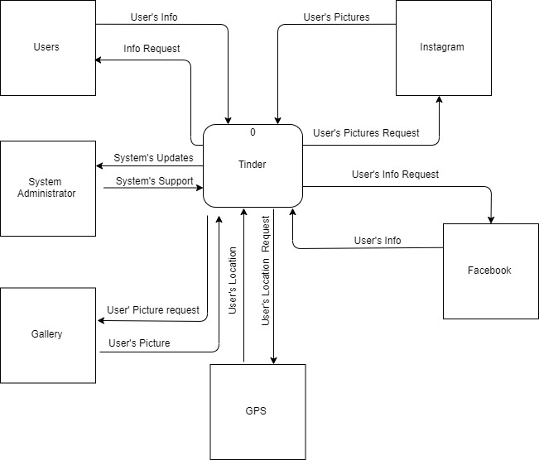

**6. Diagram 0 (Level 1) of the Existing System**

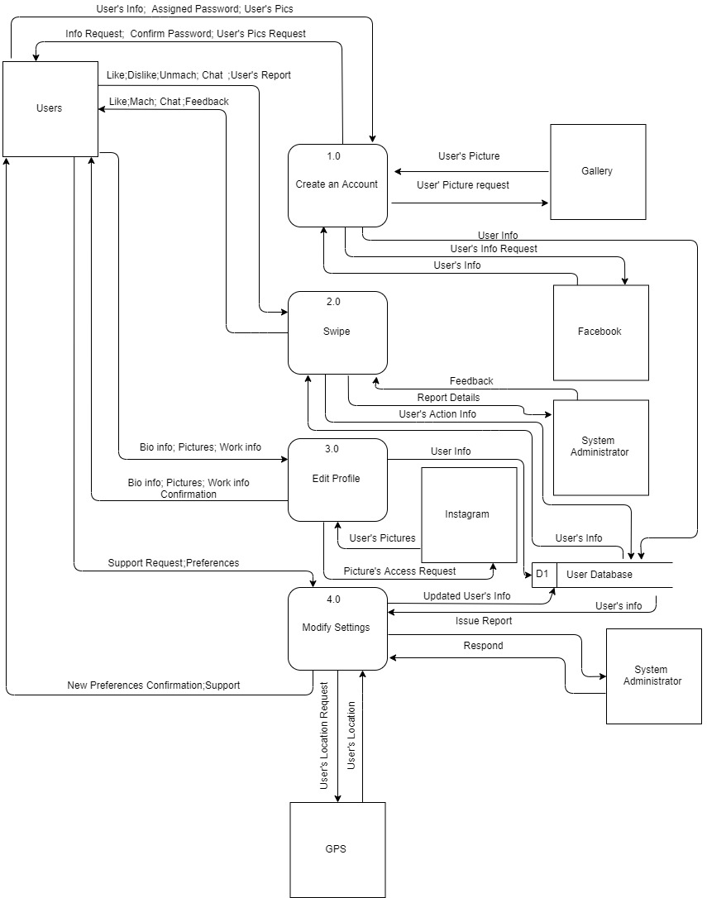

**7.Diagram 1 (level 2) of the Existing System**

* Process 1 (Create an Account)

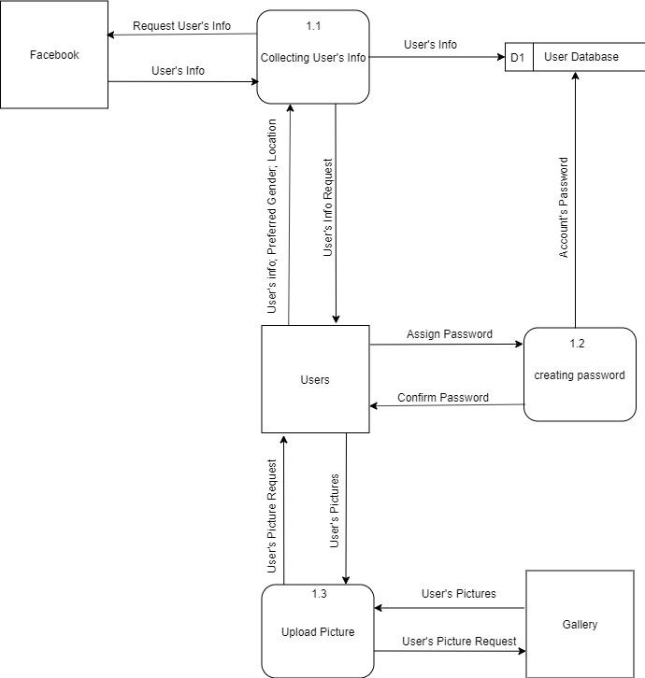

* Process 2 (Swipe)

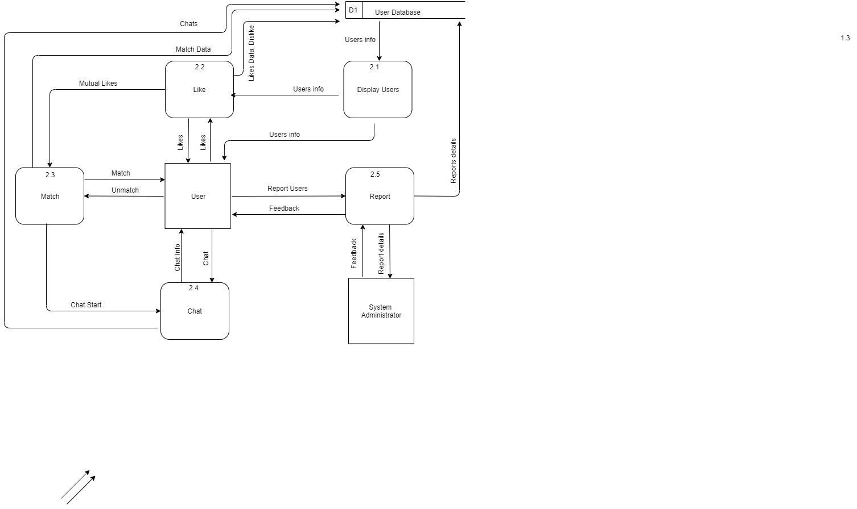

* Process 3 (Edit Profile)

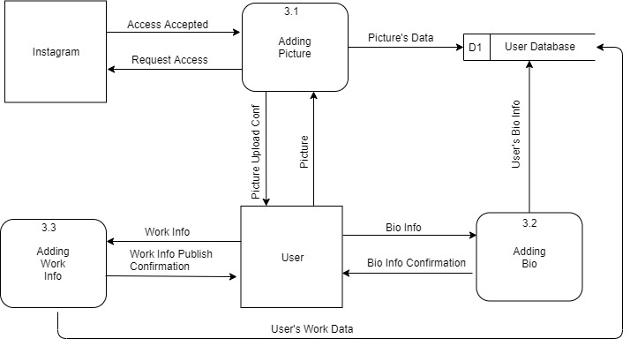

* Process 4 (Modify Settings)

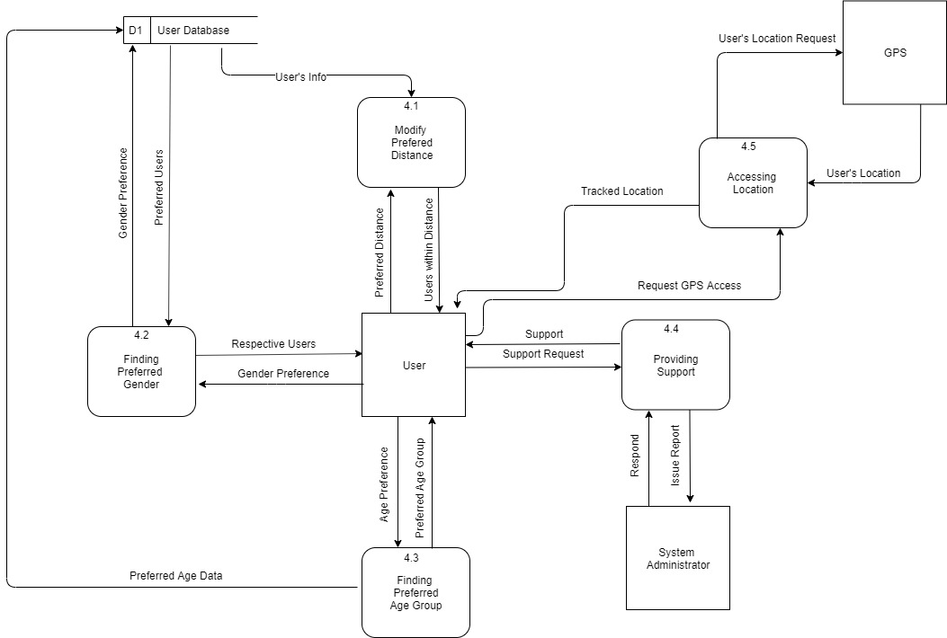

**8. Entity-Relationship Diagram of Current System**

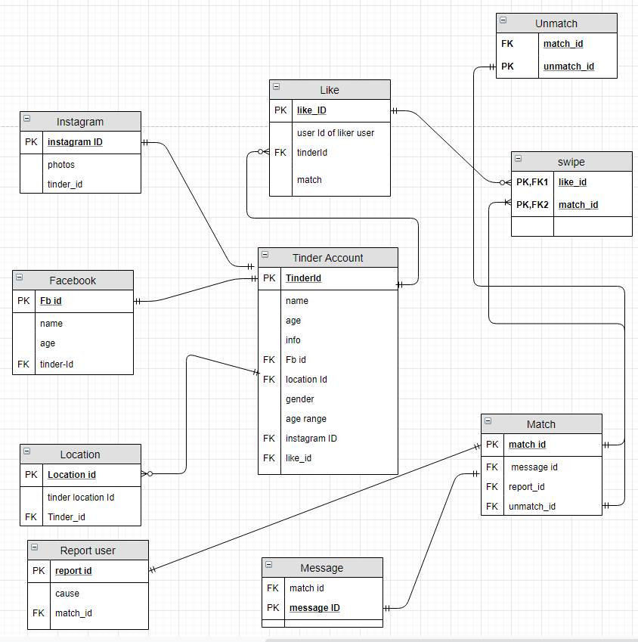

**9. Context Diagram of Proposed System**

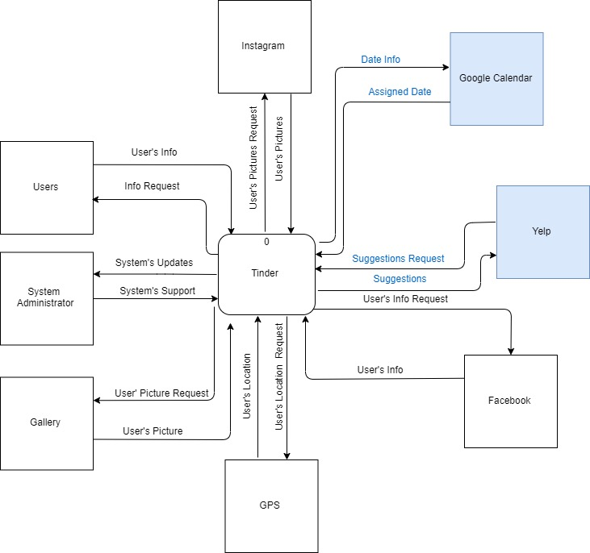

**10. Diagram 0 (Level 1) of the Proposed System**

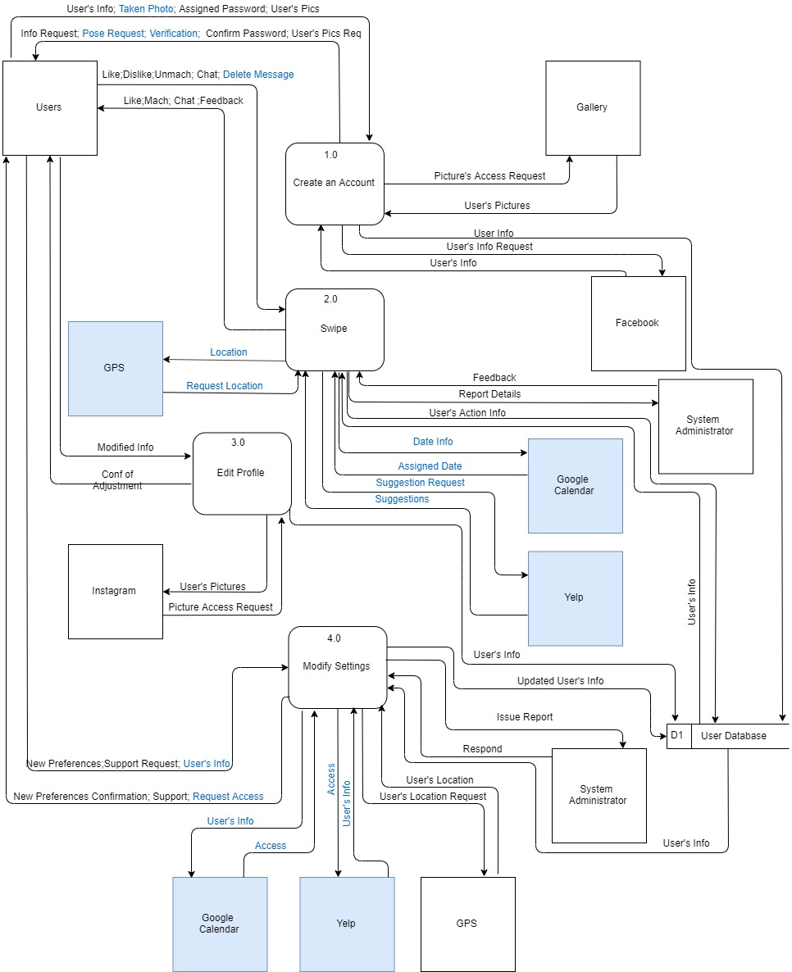

**11. Diagram 1 (level 2) of the Proposed System**

* Process 1 (Create an Account)

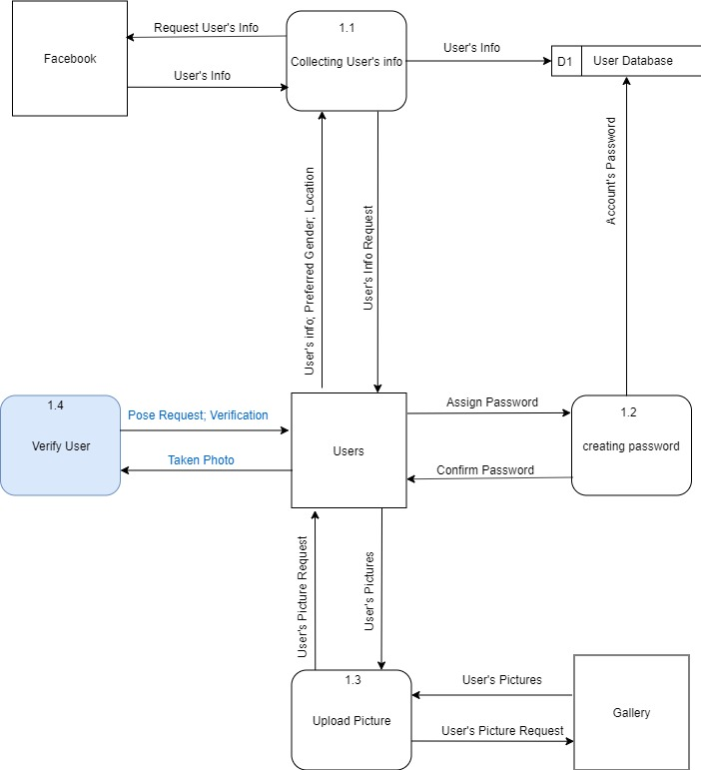

* Process 2 (Swipe)

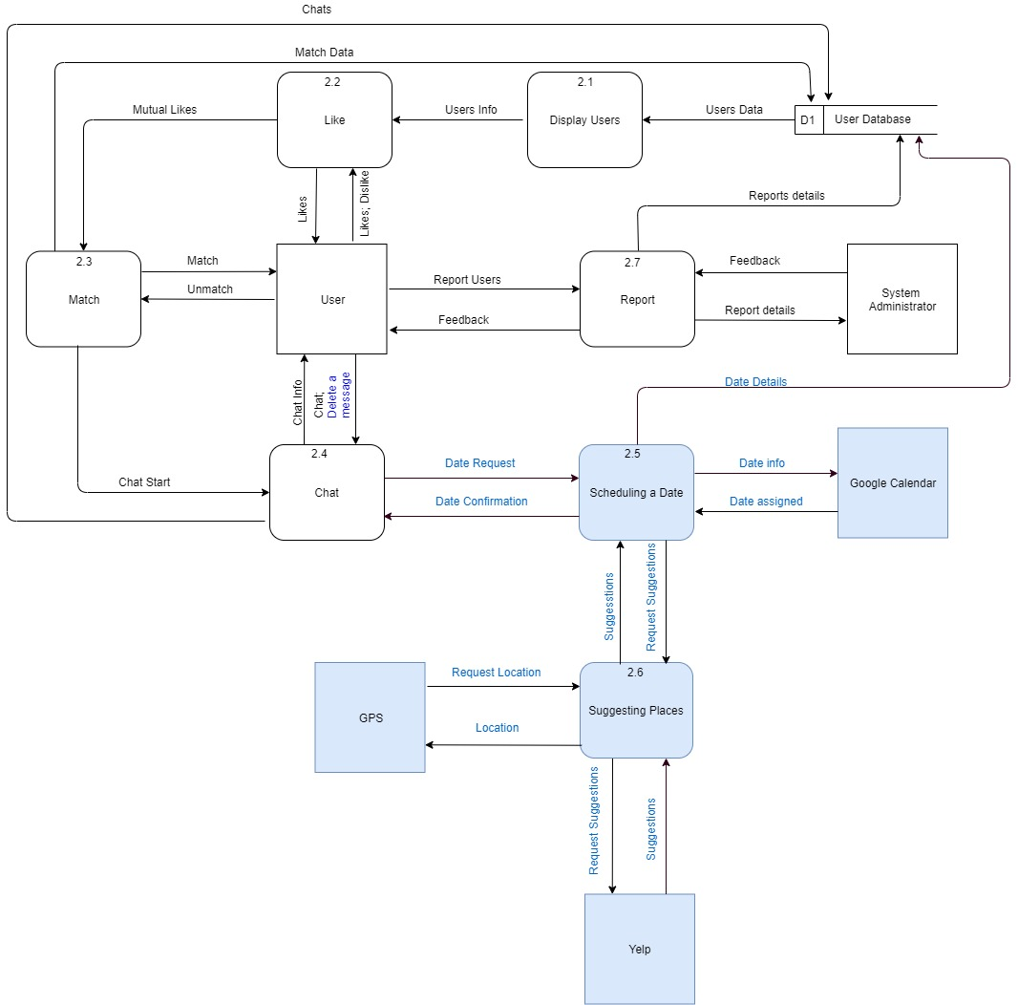

* Process 4 (Modify Settings)

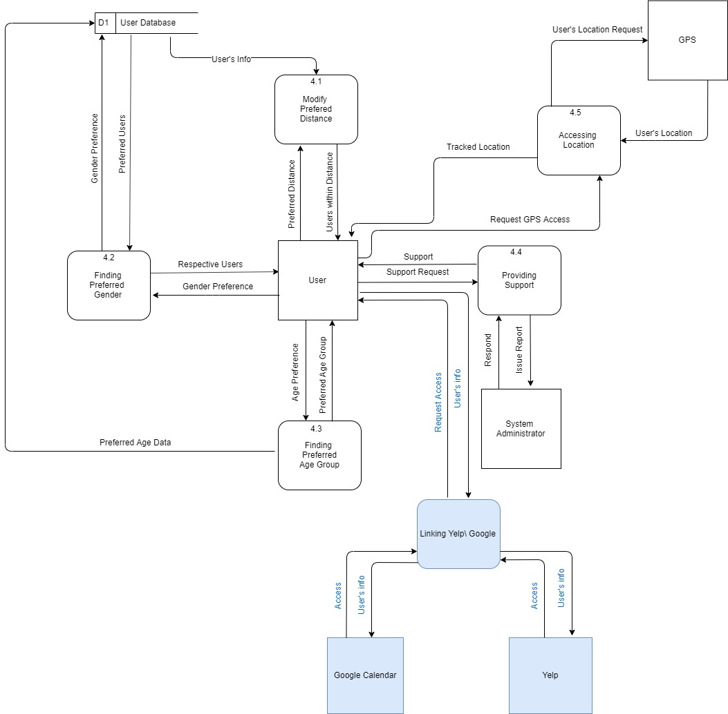

**12. Entity-Relationship Diagram of Proposed System**

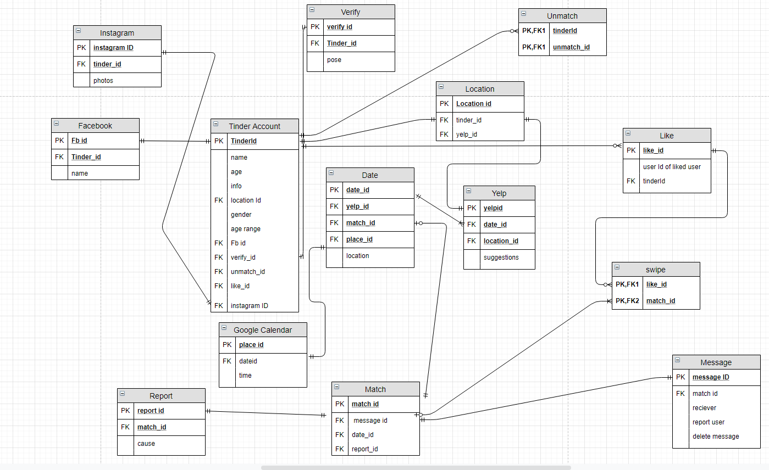

**13. Data dictionary:**

**Swipe :** it is a functionality which is used to swipe left or right on a profile to like or unlike

**Report :** It is used to report a users to the system administrator

**Match :** match is created when there is a mutual like between two users

**Yelp :** An application which suggest places to the user within the given radius

**14. Conclusion**

We can conclude by saying that Tinder has a well-built system that is easy to understand and very user-friendly but there is always room for improvement. Most of the features that we added are already proven and being used in different apps except for yelp. Collaborating with Yelp is an excellent feature as it brings in more business and also enriches user experience. This will help the users to pick the right place and also adds the date info to Google Calendar. Hence, we added multiple features and functionalities to make Tinder a better experience for a user and most of these upgrades were made from a user perspective as we also use Tinder.